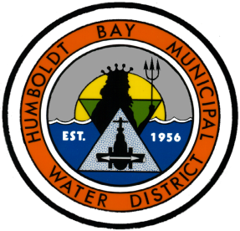
Humboldt Bay Municipal Water District
Water Supply Notification to Municipal Retail Water Customers
June 15, 2016

Pursuant to the modifications made to the Emergency Water Conservation Regulations adopted by the State Water Resources Control Board on May 18, 2016, Humboldt Bay Municipal Water District is providing the following water supply information to its Municipal Retail Water Customers for their purposes to certify water supply availability in 2016.

Background

The Mad River and supplies impounded in Ruth Reservoir are the source for potable water supply for HBMWD and its municipal customers. As reported in HBMWD’s 2015 Urban Water Management Plan (http://www.hbmwd.com/district-regulatory-plans - see p. 15), HBMWD has rights to divert up to 84,000 acre feet per year of water from the Mad River at its Essex facilities. Also noted in HBMWD’s UWMP (p. 27) is the safe yield of HBMWD’s water supply sources, which is 67 MGD, or 75,000 AF/yr. Ruth Reservoir has filled every year except 1976-77, which is the drought of record for HBMWD, and was the timeframe of the minimum supply that serves as the basis for this safe yield calculation. Of this 75,000 AF/yr of safe yield, HBMWD has the capacity to treat to potable standards 24,900 AF/yr, via its Ranney collectors, Turbidity Reduction Facility and storage and transmission system.

Water Supply Availability with Three Additional Dry Years

In 2015-16, Ruth Reservoir filled on December 21 and continued to spill until May 10, as shown in Figure 1. From that point forward, the reservoir drawdown curve has followed the normal pattern. Ruth Reservoir also filled in water years 2012-13, 2013-14, and 2014-15, thus providing the full complement of HBMWD’s water right in those years.

Assuming these three years of hydrology were to reoccur in 2017-2019, HBMWD projects that the following potable water supply would be available to its municipal retail customers during the next three years:

Year | 2017 (AF) | 2018 (AF) | 2019 (AF)
Potable water available - total | 24,900 | 24,900 | 24,900
City of Arcata | 2,526 | 2,526 | 2,526
City of Eureka | 10,699 | 10,699 | 10,699
Humboldt CSD | 2,768 | 2,768 | 2,768
McKinleyville CSD | 3,705 | 3,705 | 3,705
HBMWD | 1,357 | 1,357 | 1,357

45% - 21,500 AF
61% - 29,400 AF
80% - 38,600 AF
100% - 48,300 AF

Figure 1. Orange line represents 10-year average

